EX NO : 2  DATE : 18-06-26 | DATA CLEANING

AIM:
Perform data cleaning operations on Employee and Dirty Sales datasets.
PROBLEM STATEMENT:
Q1: Using the Employee dataset provided
https://www.kaggle.com/code/faressayah/ibm-hr-analytics-employee-attrition-performance/input
Clean the IBM Employee dataset by handling missing values, removing duplicates, standardizing categorical values, correcting datatypes, removing salary outliers using IQR, and saving the cleaned dataset.
Q2: Dirty Cars dataset
https://www.kaggle.com/datasets/ahmedmohamed2003/cafe-sales-dirty-data-for-cleaning-training?utm_source=chatgpt.com
Clean the Dirty Sales dataset by handling missing values, removing duplicate transactions, removing invalid transactions, converting dates, standardizing text fields, and saving the cleaned dataset.
PART A – EMPLOYEE:
- Identify missing values and handle them appropriately.
- Remove duplicate records.
- Standardize categorical values such as Gender and Department. ( make them into throughout the dataset)
Correct incorrect data types (Examine the data type of each attribute using df.info().
- Identify columns whose data types do not match the nature of the data convert them to appropriate types.)
- Detect and remove outliers in Salary using the IQR method.
- Save the cleaned dataset as cleaned_employee.csv.
- Compare the number of records before and after cleaning.
- Summarize the cleaning operations performed.

CODE:
import pandas as pd
# 1. Load Dataset
df = pd.read_csv(r"D:\SEM_5\ML\datasets\Data cleaning\employee\WA_Fn-UseC_-HR-Employee-Attrition.csv")
print("Original Shape:", df.shape)
records_before = len(df)

# 2. Missing Values
print("\n========== MISSING VALUES ==========")
print(df.isnull().sum())
missing_before = df.isnull().sum().sum()
for col in df.columns:
if df[col].dtype == "object":
df[col] = df[col].fillna(df[col].mode()[0])
else:
df[col] = df[col].fillna(df[col].median())
missing_after = df.isnull().sum().sum()

# 3. Remove Duplicate Records
duplicate_count = df.duplicated().sum()
df = df.drop_duplicates()
print("\nDuplicates Removed:", duplicate_count)
# 4. Standardize Categorical Values
if "Gender" in df.columns:
df["Gender"] = (df["Gender"].astype(str).str.strip().str.lower().replace({"male": "Male","female": "Female"}))
if "Department" in df.columns:
df["Department"] = (df["Department"].astype(str).str.strip().str.title())

# 5. Check and Correct Data Types
print("\n========== DATA TYPES BEFORE ==========")
df.info()
for col in df.columns:
if ("Age" in col or "Income" in col or "Rate" in col or "Years" in col):
df[col] = pd.to_numeric(df[col], errors="coerce")
print("\n========== DATA TYPES AFTER ==========")
df.info()

# 6. Detect and Remove Salary Outliers Using IQR Method
salary_col = "MonthlyIncome"
Q1 = df[salary_col].quantile(0.25)
Q3 = df[salary_col].quantile(0.75)
IQR = Q3 - Q1
lower_bound = Q1 - (1.5 * IQR)
upper_bound = Q3 + (1.5 * IQR)
outliers_removed = len(df [ (df[salary_col] < lower_bound) | (df[salary_col] > upper_bound) ])
df = df[ (df[salary_col] >= lower_bound) & (df[salary_col] <= upper_bound)]

# 7. Save Cleaned Dataset
df.to_csv("cleaned_employee.csv", index=False)
records_after = len(df)

# 8. Cleaning Summary
print("\n========== CLEANING SUMMARY ==========")
print("Records Before Cleaning :", records_before)
print("Records After Cleaning :", records_after)
print("Missing Values Found :", missing_before)
print("Missing Values Removed :", missing_before - missing_after)
print("Duplicates Removed :", duplicate_count)
print("Salary Outliers Removed :", outliers_removed)
print("\nCleaned dataset saved as:")
print("cleaned_employee.csv")

OUTPUT:
1.
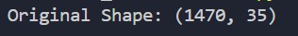

2.
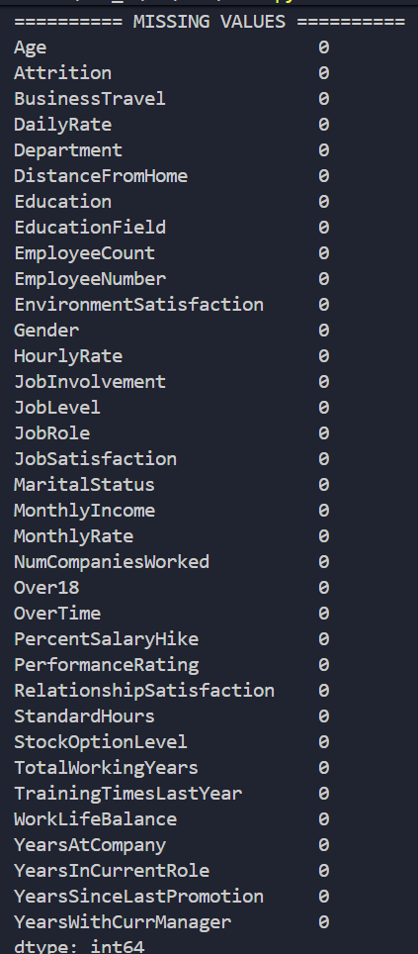

3.

5.
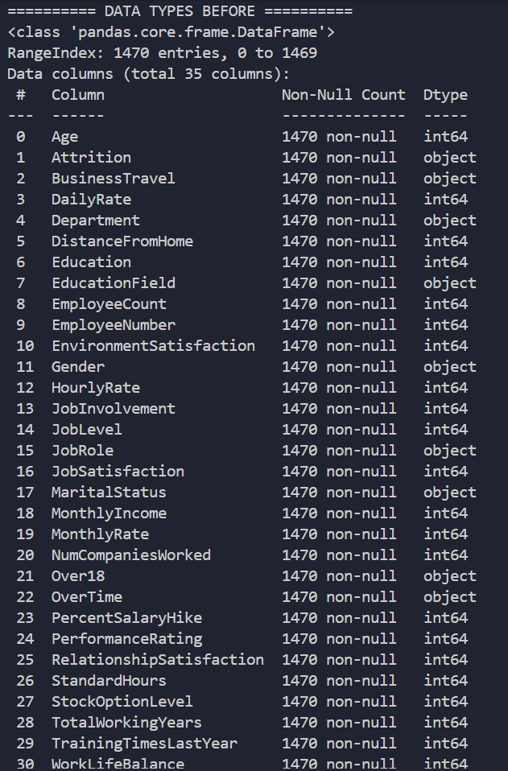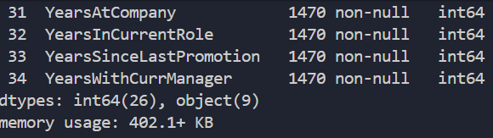

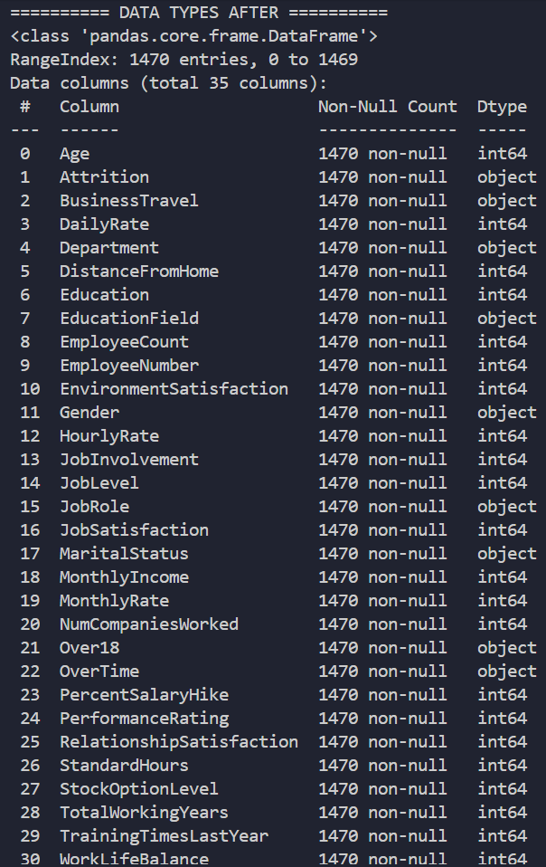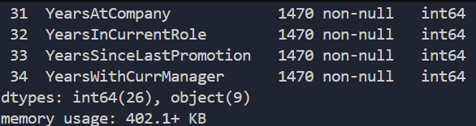

7.
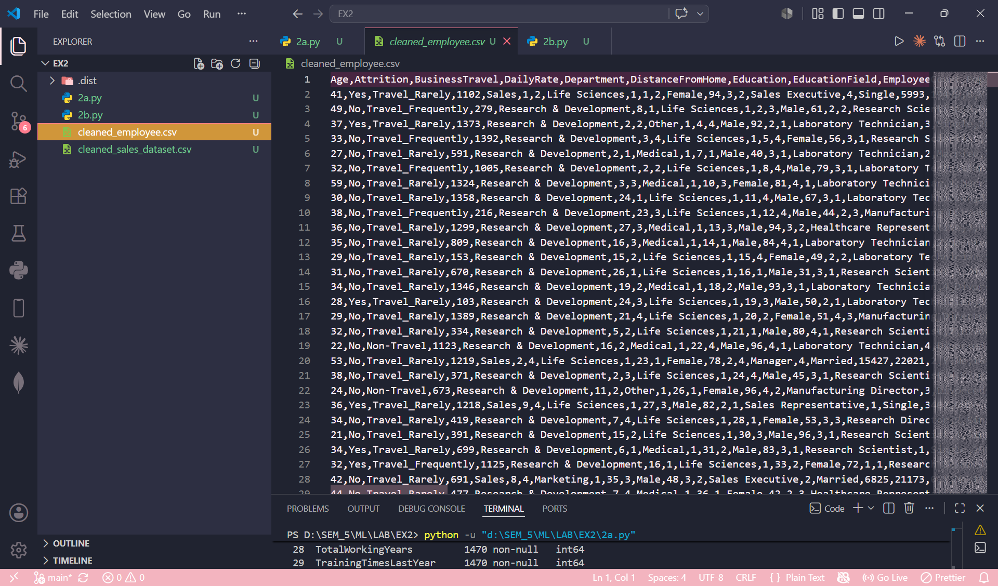

8.
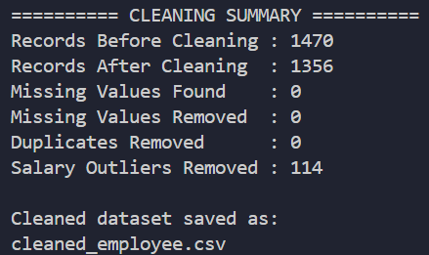

PART B – DIRTY CARS DATA
Perform the following data cleaning tasks:
- Load the dataset and display basic information.
- Identify columns containing missing values and handle them appropriately.
- Detect and remove duplicate transactions.
- Find records with negative or zero Quantity and UnitPrice values and clean the dataset.
- Convert InvoiceDate into a proper date-time format.
- Standardize text fields such as Description by removing extra spaces and converting to a consistent case.
- Generate a summary showing:
- Number of missing values removed
- Number of duplicate records removed
- Number of invalid transactions removed
- Save the cleaned dataset as a new CSV file.
CODE:
import pandas as pd

# 1. Load Dataset
df = pd.read_csv( r"D:\SEM_5\ML\datasets\Data cleaning\Dirty Cars\archive\dirty_cafe_sales.csv")
print("Original Shape:", df.shape)
records_before = len(df)

# 2. Basic Information
print("\nDataset Info")
df.info()

# 3. Missing Values
print("\nMissing Values")
print(df.isnull().sum())
missing_before = df.isnull().sum().sum()
for col in df.columns:
if df[col].dtype == "object":
df[col] = df[col].fillna(df[col].mode()[0])
missing_after = df.isnull().sum().sum()
missing_removed = missing_before - missing_after

# 4. Remove Duplicate Transactions
duplicates_removed = df.duplicated().sum()
df = df.drop_duplicates()

# 5. Convert Numeric Columns
df["Quantity"] = pd.to_numeric(df["Quantity"], errors="coerce")
df["Price Per Unit"] = pd.to_numeric(df["Price Per Unit"], errors="coerce")
df["Total Spent"] = pd.to_numeric(df["Total Spent"], errors="coerce")
df["Quantity"] = df["Quantity"].fillna(df["Quantity"].median())
df["Price Per Unit"] = df["Price Per Unit"].fillna( df["Price Per Unit"].median())
df["Total Spent"] = df["Total Spent"].fillna( df["Total Spent"].median())

# 6. Remove Invalid Transactions
invalid_transactions = len( df[ (df["Quantity"] <= 0) | (df["Price Per Unit"] <= 0)])
df = df[ (df["Quantity"] > 0) & (df["Price Per Unit"] > 0)]

# 7. Convert Transaction Date
df["Transaction Date"] = pd.to_datetime( df["Transaction Date"], errors="coerce")
invalid_dates = df["Transaction Date"].isnull().sum()
df = df.dropna(subset=["Transaction Date"])

# 8. Standardize Item Names
df["Item"] = ( df["Item"].astype(str).str.strip().str.lower())
df["Payment Method"] = (df["Payment Method"].astype(str).str.strip().str.title())
df["Location"] = (df["Location"] .astype(str).str.strip().str.title())

# 9. Save Clean Dataset
df.to_csv("cleaned_sales_dataset.csv", index=False)
records_after = len(df)

# 10. Cleaning Summary
print("Records Before Cleaning :", records_before)
print("Records After Cleaning :", records_after)
print("Missing Values Removed :", missing_removed)
print("Duplicate Records Removed :", duplicates_removed)
print("Invalid Transactions Removed :", invalid_transactions)
print("Invalid Dates Removed :", invalid_dates)
print("\nCleaned dataset saved as:")
print("cleaned_sales_dataset.csv")

OUTPUT:
1.

2.
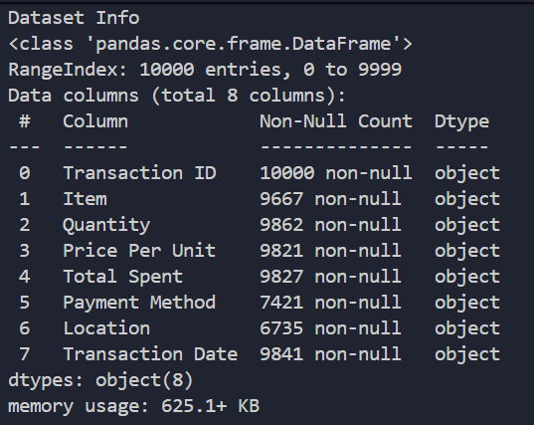

3.
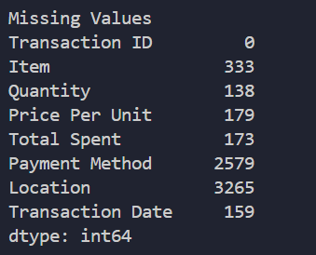

9.
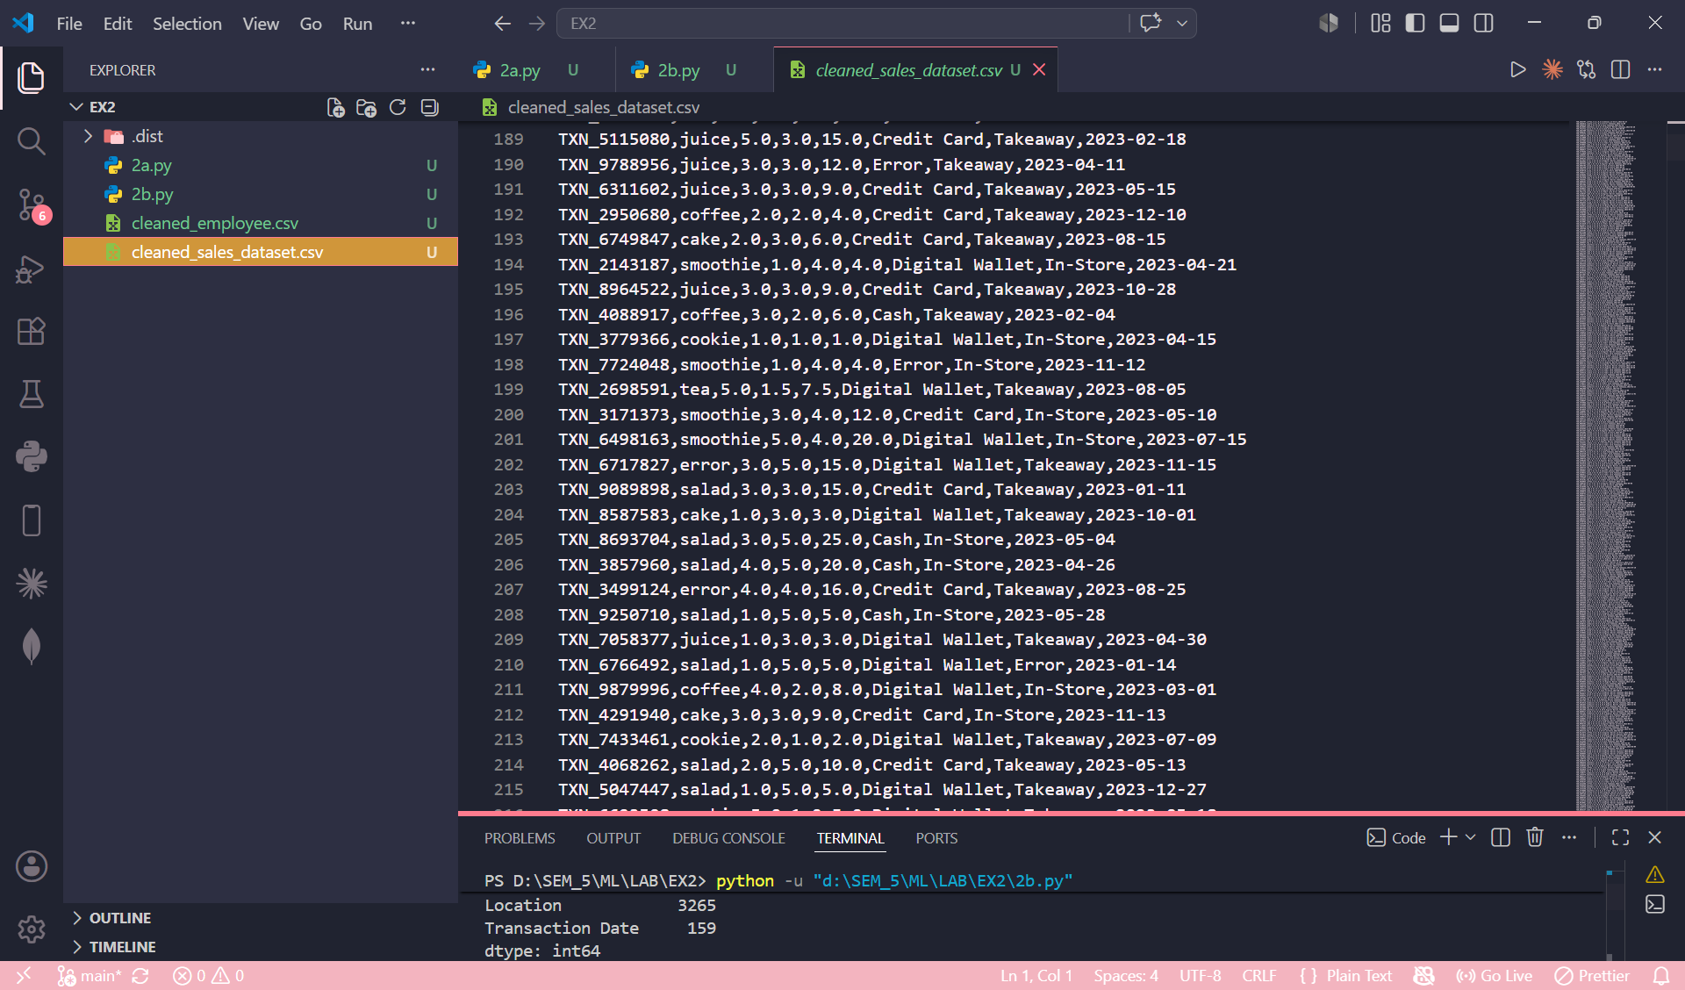

10.
